**Git Commands**

**What is Git?**

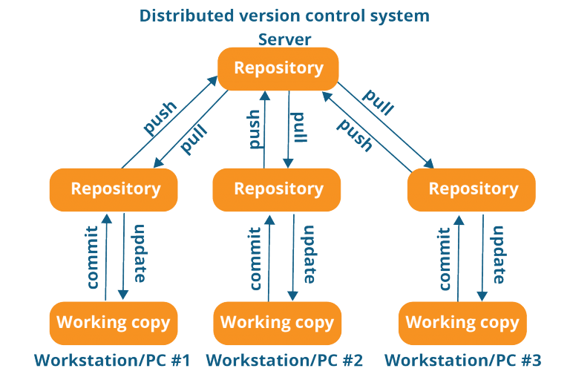

Git is a free, open-source distributed version control system. This tool handles everything from small to very large projects with speed and efficiency. Linus Torvalds created it in 2005 to develop the Linux Kernel. Git has the functionality, performance, security, and flexibility that most teams and individual developers need.

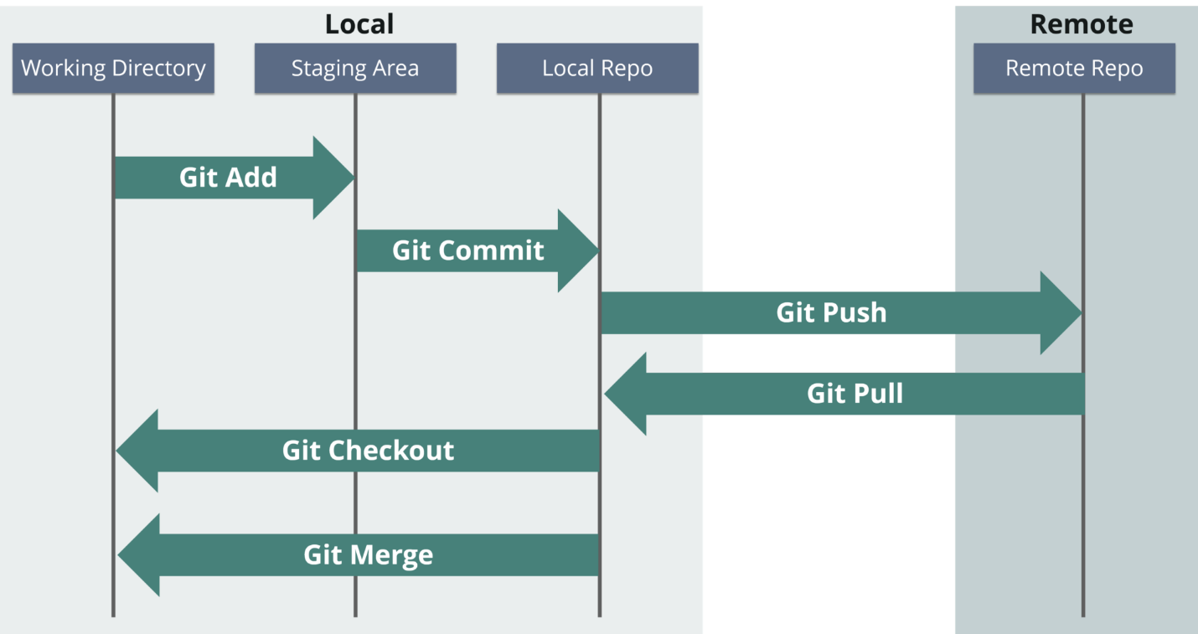

Tools like Git enable communication between the development and the operations team. When you are developing a large project with a huge number of collaborators, it is very important to have communication between the collaborators while making changes in the project. Commit messages in Git plays a very important role in communicating among the team. The bits and pieces that we all deploy lie in the Version Control system like Git. To succeed in DevOps, you need to have all of the communication in Version Control. Hence, Git plays a vital role in succeeding at DevOps.

**git init**

**Usage**: git init [repository name]

This command creates a new repository.

**init-linux commands in devops-Edurekagit config**

**Usage**:*git config --global user.name “[name]”*

**Usage**: *git config --global user.email “[email address]”*

This command sets the author name and email address respectively. This is useful information with the commits.

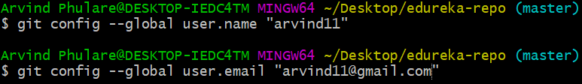

**git clone**

**Usage**:*git clone [url]*

This command lets you get a copy of a repository from an existing URL.

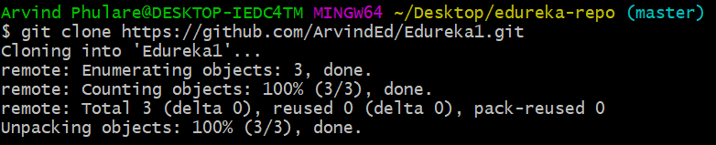

**git add**

**Usage:***git add [file]*

This command adds a file to the staging area.

**add1-linux commands in devops-EdurekaUsage:** *git add \**

This command adds one or more to the staging area.

**add2-linux commands in devops-Edureka**

**git commit**

**Usage:** *git commit -m “[ Type in the commit message]”*

This command records or snapshots the file permanently in the version history.

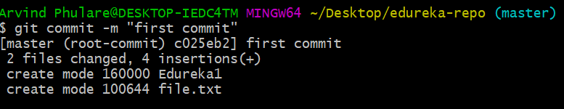**Usage:** *git commit -a*

This command commits any files you’ve added with the git add command and also commits any files you’ve changed since then.

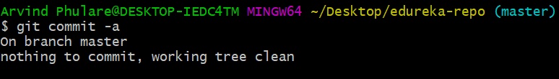

**git status**

**Usage:***git status*

The git status command displays the state of the working directory and the staging area.This command lets you see the changes that are in the staging, those that are not staged and are not tracked by Git.

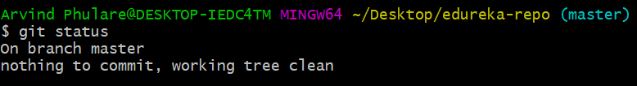

**git show**

**Usage:** *git show [commit]*

This command shows the metadata and content changes of the specified commit.

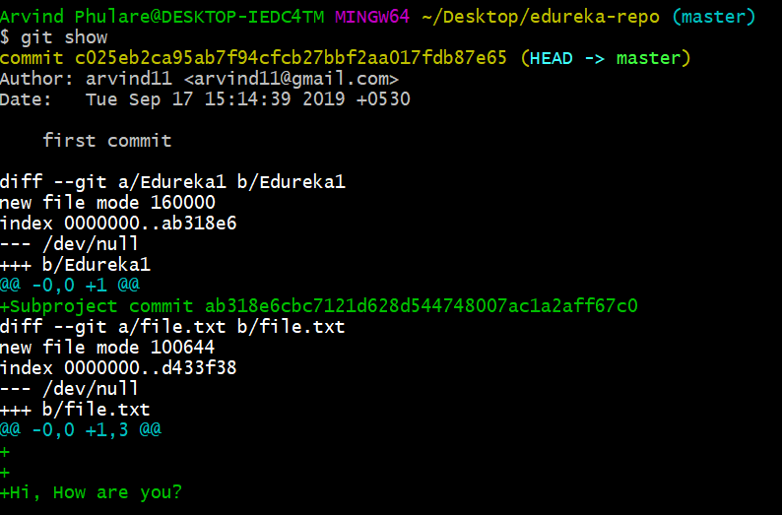

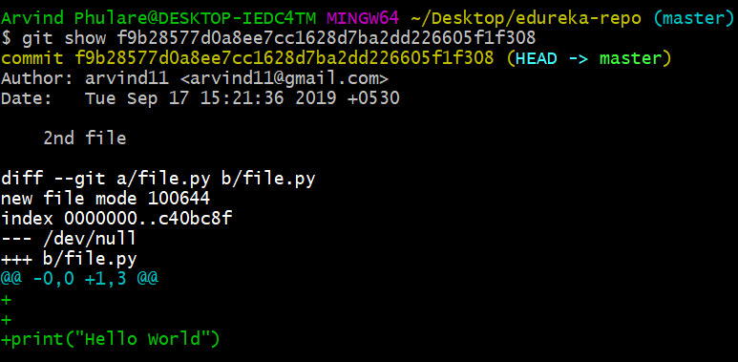

**git rm**

**Usage:** *git rm [file]*

This command deletes the file from your working directory and stages the deletion.

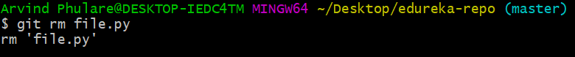

**git remote**

**Usage:** *git remote add [variable name] [Remote Server Link]*

This command connects your local repository to the remote server.



**git push**

**Usage:** *git push [variable name] master*

This command sends the committed changes of the master branch to your remote repository.

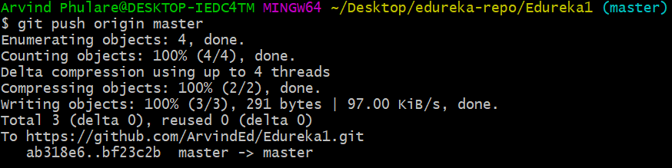

**Usage:** *git push [variable name] [branch]*

This command sends the branch commits to your remote repository.

**Usage:** *git push –all [variable name]*

This command pushes all branches to your remote repository.

**Usage:** *git push [variable name] :[branch name]*

This command deletes a branch on your remote repository.

**git pull**

**Usage:** *git pull [Repository Link]*

This command fetches and merges changes on the remote server to your working directory.

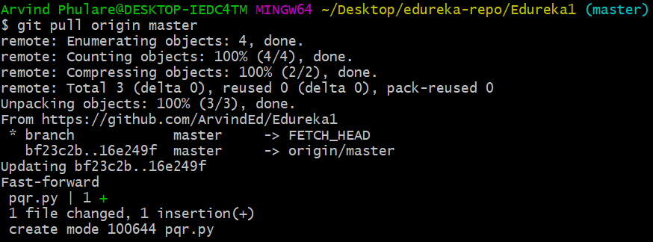

**git branch**

**Usage:***git branch*

This command lists all the local branches in the current repository.

**Usage:** *git branch [branch name]*

This command creates a new branch.

**branch1-linux commands in devops-EdurekaUsage:** *git branch -d [branch name]*

This command deletes the feature branch.

**git checkout**

**Usage:** *git checkout [branch name]*

This command lets you switch from one branch to another.

**Usage:***git checkout -b [branch name]*

This DevOps Linux command creates a new branch and also switches to it.

**git merge**

**Usage:** *git merge [branch name]*

This DevOps Linux command merges the specified branch’s history into the current branch.

**git rebase**

**Usage:** *git rebase [branch name]*

*git rebase master* – This command will move all our work from the current branch to the master.